Electronic Devices and Circuits
(EL-225)
LABORATORY MANUAL
FALL 2021


(LAB # 01)
Familiarization to Proteus and Lab Equipment
Engr. Maria Nasir

Student Name: ___________________________

Roll No: _____________ Section: ___________

Date performed: _____________________, 2021

Manual Submission Date: ______________, 2021
_______________________________
LAB ENGINEER SIGNATURE & DATE
MARKS AWARDED: /10

LAB: | 01 | Familiarization to Proteus and Lab Equpiment

Objectives:
➢ Introduction of PROTEUS and ARES.
➢ To understand PROTEUS as designing and simulation tools for electric circuits.
➢ Introduction to lab equipment to be used in Electronics Lab.
Equipment required:
➢ Computer/ Laptop
➢ Proteus Software
Introduction:
Proteus is a software for microprocessor simulation, schematic capture, and printed circuit board (PCB) design. It is developed by Labcenter Electronics.
Getting started with PROTEUS:
In order to open the Proteus Window, follow the following steps:
➢ Click on Start Menu at the bottom of screen.
➢ Click on All Programs icon. A program list will open as shown below
➢ Now click on PROTEUS folder and then click on PROTEUS icon.
➢ A window like the one shown below will pop up.
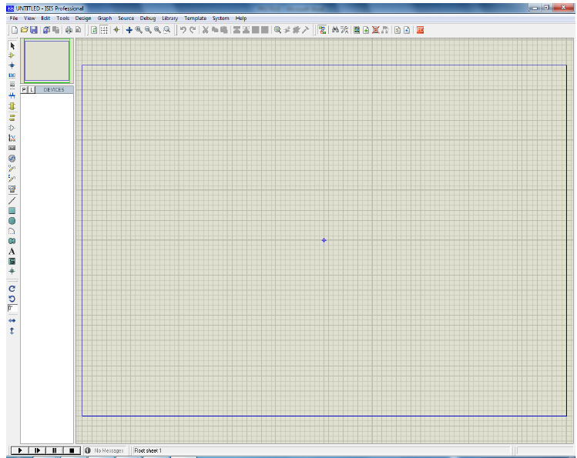
Fig 1.1: PROTEUS ISIS Window

➢ The Editing Window:
The largest area of the screen is called the Editing Window, and it acts as a window for the drawing - this is where components are placed and wired-up.
➢ The Overview Window:
The smaller area at the top right of the screen is called the Overview Window.
➢ Menu Bar:
The Menu Bar runs across the top row of the screen. Its main purpose is the selection of commands from the menus.
Fig 1.2: Menu Bar
➢ The Toolbars:
ISIS provides access to a number of its commands and modes through the use of toolbars. The toolbars can be dragged to any of the four edges of the ISIS application window.
➢ File/Print Commands
➢ Display Commands
➢ Mode Selector Toolbar
➢ Orientation Toolbar
➢ The Object Selector:
The Object Selector is used for picking components, terminals, generators, graph types and so on from those that are available.
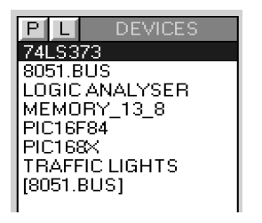
Fig 1.3: The Object Selector

Steps to make a Circuit on PROTEUS:
For the sake of understanding, a simple circuit that would demonstrate Voltage dividing Rule is constructed. With these examples, you would be able to use some basic Electrical Instruments:
We know that when two different resistors are connected in series, the voltage drop across each of them would be different but sum of the individual voltage drops would be equal to voltage of the battery. A simple voltage divider circuit is shown Fig 1.4:
Fig 1.4: Voltage Divider Circuit
In this lab, you will find the voltage drop across R1 and R2. In order to draw the above circuit in PROTEUS, follow the following steps:
- Click on P to pick the devices to be used. A window like the one shown below will appear.

Fig 1.5: The Object Select Window
- As we need resistors and battery so write resistor in the ‘Keywords’ tab.
Fig 1.6: Picking an object from object selector
- To select the resistor double click the resistor option. The selected component will appear in devices section of the main window.
Fig 1.7: Transferring a component to Main Window

- In order to select battery, write battery in the search window and select the DC voltage source (First Option).
Fig 1.8: Selection of Battery

- Now close the Pick Devices Window.
In order to draw the circuit follow the following procedure:
- Click the required device in Device table and then click in the circuit-making window. The component will appear in the circuit window.
Fig 1.9: Placing components in Circuit Making Window
- In order to assign different values to the components, Click the right hand side button of the mouse twice, while keeping the pointer on the component to be selected. For example if you want to change the value of R1, take the mouse pointer on the resistor R1 and click the right side button of the mouse twice. A window like the one shown below will appear.
Fig 1.10: Assigning values to the components
For this particular example, take
V = 12V
R1 = 5k ohm
R2 = 10k ohm

- In order to draw a line to make connections between two components, while pressing the left button of the mouse, drag the mouse from required terminal of the first device to the required terminal of the second device.

Fig 1.11: Connection between components
- Now complete the circuit according to the diagram shown in fig 1.4.
Fig 1.12: Complete Circuit

- This circuit may work properly but in complex circuit we may face some problems. To avoid this, provide common ground to the circuit. This can be done by selecting GROUND option in the TERMINAL MODE tab on left side of the main window. Connect the ground terminal as shown in the diagram below:
Fig 1.13: Connecting the ground
- In order to measure voltage across any of the resistor a voltmeter will be needed. For this purpose select DC VOLTMETER from VIRTUAL INSTRUMENTS MODE on the left side of the screen and connect it parallel to R1 as shown in the Fig below:

Fig 1.14: Connecting the measuring instruments

- Now run the circuit by pressing the start button present on bottom left side of the screen.
Fig 1.15: Simulating a circuit
- Similarly, voltage across R2 can be found. For this purpose connect voltmeter in parallel to R2.
Fig 1.16:Simulating the complete circuit

NOTE:
In order to make changes in the circuit, first stop the simulation and then make changes.

LAB TASKS
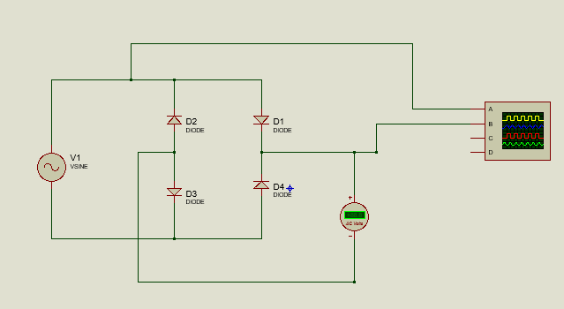
Task 1:
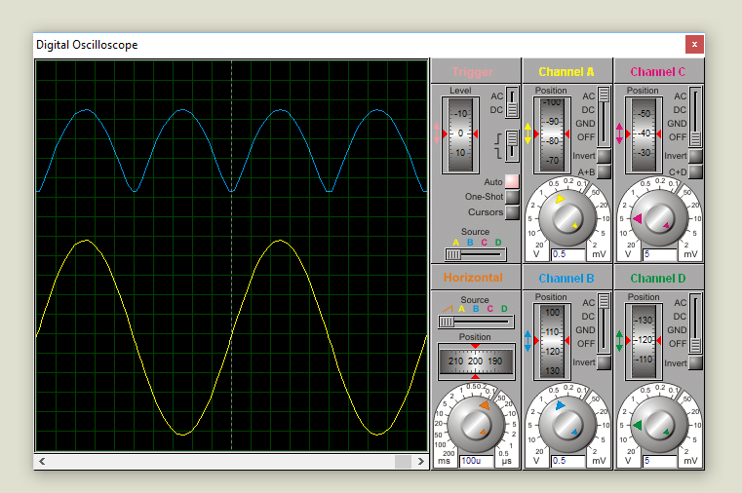

Task 2:
Construct the circuit as shown below, on proteus and simulate. Vary the input voltage Vin according the values given in the table and by using ampere meter and volt meter record the values of Id and Vd.

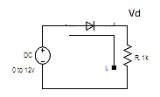
+ $V_{d}$ -

R = 1 kΩ
DC input
0 to 12V
4.310.

Vin  (V) | Simulated Results
Vin  (V) | Vd (V) | Id (mA) | Slope (Id/Vd)
0.0 | 0 | 0 | -
0.2 | 0.2 | 0 | 0
0.4 | 0.4 | 0 | 0
0.6 | 0.57 | 0.03 | 0.05
0.8 | 0.61 | 0.19 | 0.31
1.0 | 0.63 | 0.37 | 0.59
1.2 | 0.64 | 0.56 | 0.88
1.4 | 0.65 | 0.75 | 1.15
1.6 | 0.65 | 0.95 | 1.46
1.8 | 0.66 | 1.14 | 1.73
2.0 | 0.66 | 1.34 | 2.03
3.0 | 0.68 | 2.32 | 3.41
4.0 | 0.69 | 3.31 | 4.80
5.0 | 0.69 | 4.31 | 6.25
6.0 | 0.70 | 5.30 | 7.57
7.0 | 0.70 | 6.30 | 9
8.0 | 0.71 | 7.29 | 10.27
9.0 | 0.71 | 8.29 | 11.68
10.0 | 0.71 | 9.29 | 13.08

Student's feedback: Purpose of feedback is to know the strengths and weaknesses of the system for future improvements. This feedback is for the 'current lab session'. Circle your choice:
[-3 = Extremely Poor, -2 = Very Poor, -1 = Poor, 0 = Average, 1 = Good, 2 = Very Good, 3 = Excellent]:
The following table should describe your experience with:
S# | Field | Rating | Describe your experience in words
1 | Overall Session
  -3 | -2 | -1 | 0 | 1 | 2 | 3
2 | Lab Instructor
  -3 | -2 | -1 | 0 | 1 | 2 | 3
3 | Lab Staff
  -3 | -2 | -1 | 0 | 1 | 2 | 3
4 | Equipment
  -3 | -2 | -1 | 0 | 1 | 2 | 3
5 | Atmosphere
  -3 | -2 | -1 | 0 | 1 | 2 | 3
Any other valuable feedback: __________________________________________________________________________
__________________________________________________________________________
__________________________________________________________________________

Student's Signature: _________________________________

MARKS  AWARDED | Attitude | Neatness | Correctness of results | Initiative | Originality | Conclusion | TOTAL
TOTAL | 10 | 10 | 10 | 20 | 20 | 30 | 100
EARNED

Lab Instructor's Comments:_________________________________________________________________
__________________________________________________________________________
__________________________________________________________________________

Lab Instructor's Signature: ________________________

